# Iteration Report

This report covers step one and two of the refactoring process. Although testing already exists coverage is not nearly close to 100%. The purpose of this iteration is to expand on the current tests to create 100% coverage.

## Tasks Completed

1. Refactored the validation method
2. Refactored the build_graph method

## Coverage Output Original

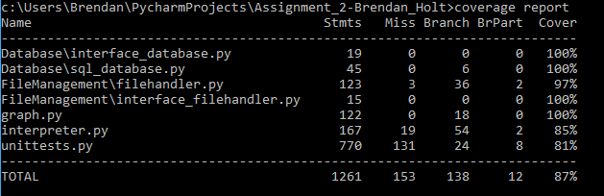

## Coverage Output After

